Basic Business
April 13-17

What you will need:
Workbook: Keeping Financial Records
Chapter 9 packet
Pen/pencil
Calculator

What you will do:

M 4/13 | T 4/14 | W 4/15 | Th 4/16 | F 4/17
Complete Problem 43-1 (if you did not do this last week)  Add a photo of YOURSELF to our Teams classroom | Watch the Video Lesson for Job 43-2 Completing Sales Invoice for Wholesale pg. 343 TB/pg. 355 WB | Post to Discussion Board in TEAMS (read instructions below)  Complete Problem 43-2 all sales | Watch the Video Lesson for Job 44 pg. 348 TB/pg. 364 WB | Complete Problem 44-1
Use the boxes below to CHECK when above task is completed (optional):

What you will learn:
How to keep records for Accounts Receivable Clerks.

How you will complete your work:
If you did not do this last week: WATCH VIDEO LESSON and Complete Job 43 Problem 1
- Chapter 9 pg. 345 TB/pg. 355 WB
- In TEAMS, look for the Video Lessons on the left panel and open
- At any point, if the video moves too fast, click pause and go back. You can also take notes, pausing when you need to.
- Complete Job 43 Problem 1 in your workbook.

Turn in Job 43 Problem 1
- Follow the instructions from last week for Turning in Practice Assignment
- Take a photo of Problem 1 and turn it in to Assignment 43-1

Add a Photo:
We miss you and it will be great to see your face! Add a NICE and school appropriate photo of yourself to our Teams classroom!

- Go to your Team classroom. In the upper right corner, click the circle for your profile. Click “Change picture”
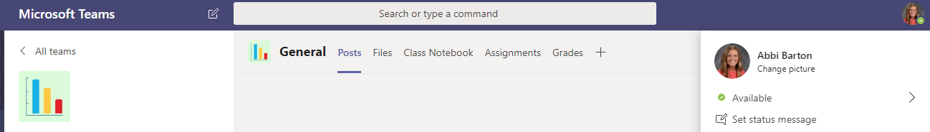

- In the next window, click “Upload picture.” Find the photo saved in your files.

Don’t have a photo? EMAIL ME! I will send you your yearbook photo

WATCH VIDEO LESSONS and Complete Problems
- In TEAMS, look for the Video Lessons on the left panel and open
- At any point, if the video moves too fast, click pause and go back. You can also take notes and complete the sample problem, pausing when you need to.
- Complete the assigned problems in your workbook.

Turn in Problems
- Take a photo of ONE problem/page from each Job and turn it in to the corresponding Assignment
  - Job 43-2: take a picture of Sale #3 and turn-in, for Job 43-1: take a picture of pg. 365

Make a Discussion Board POST in Teams
- One the left side of your Team, click Discussion Board.

- Post: How is Remote Learning going? Tell us how you feel about it, what has been hard, what has been difficult, what you think about this new school. Is there anything about “school” that could be improved? What’s the biggest struggle been? At least a couple sentences.

- REPLY to ONE of your classmates –give helpful feedback, suggestions, relate to their feelings. At least a couple sentences.

